**Smart Home Automation System**

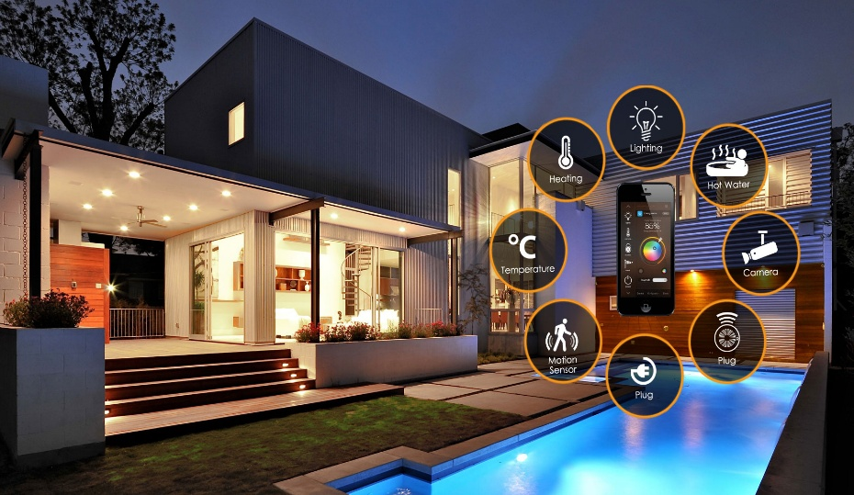

**Course Tile: System Analysis & Design**

**Course Code: CSE 306**

**Group Members**

|  |  |
| --- | --- |
| **Name** | **Registration No.** |
| **Md Kayes Ahammed Biplob** | **22101151** |
| **Anika Nawer Nabila** | **22101152** |
| **Abdullah Al- Mamun** | **22101158** |

**Smart Home Automation System**

**Introduction**

In an era driven by technology, the concept of smart homes has become increasingly popular, promising convenience, efficiency, and enhanced security. However, the reality of modern living often paints a different picture—one marked by disconnected devices, complex installations, and lingering security concerns. Despite the allure of automation, users frequently encounter frustration as their smart devices fail to seamlessly communicate or integrate.

This project aims to address these challenges by developing a smart home automation system that prioritizes simplicity, security, and centralized control. While existing solutions have made strides, gaps remain, leaving tech enthusiasts, homeowners, and security-conscious individuals searching for a more reliable and user-friendly experience. Through innovative approaches and enhanced protocols, our goal is to create a smarter, safer, and more intuitive home automation system that transforms the way users interact with their living spaces.

**Problem Statement**

*The Reality of Modern Living*

* **Disconnected Devices**  
  Devices don’t communicate efficiently, leading to frustration.
* **Complexity of Setup**  
  Most smart systems are difficult to install and maintain.
* **Security Concerns**  
  Smart homes face vulnerabilities and potential breaches.

**Proposed Solution(s)**

*An Attempt to Simplify, But...*

* **Centralized Control Hub**  
  One place to manage all your devices—though not perfect.
* **Simplified Setup Process**  
  Easier to configure, but there’s always something missing.
* **Enhanced Security Protocols**  
  Better security, but vulnerabilities still linger.

**Target Audience**

*For Those Who Hope for a Better Future*

* **Tech Enthusiasts**  
  Who dream of flawless automation but face constant glitches.
* **Homeowners**  
  Hoping for convenience but often finding more complexity.
* **Security-Conscious Individuals**  
  Looking for peace of mind, though concerns remain.

### ****Requirements for Smart Home Automation System****

### Functional Requirements

1. **Device Control:** Remotely control various devices (lights, thermostats, appliances) from a smartphone or tablet.
2. **Voice Control:** Enable voice commands to control devices using a virtual assistant.
3. **Scene Automation:** Create predefined scenes (e.g., "Good Morning," "Movie Night") to automate multiple device actions.
4. **Security Features:** Include security features like door/window sensors, motion detectors, and camera integration.
5. **Energy Management:** Monitor energy consumption and provide recommendations for optimization.
6. **Weather Integration:** Integrate with weather data to adjust devices accordingly (e.g., close blinds on sunny days).
7. **Guest Access:** Allow for temporary guest access to control specific devices or areas of the home.
8. **Scheduling:** Set schedules for device actions (e.g., turn off lights at a specific time).
9. **Notifications:** Send notifications for device status changes, security alerts, or maintenance reminders.
10. **Integration with Other Systems:** Integrate with other smart home systems or platforms (e.g., Google Home, Amazon Alexa).
11. **Remote Monitoring:** Monitor your home's status (e.g., temperature, security) from anywhere.
12. **Customization:** Allow users to customize the system's appearance, preferences, and device settings.
13. **Multi-User Support:** Support multiple users with different access levels and preferences.
14. **Accessibility Features:** Ensure the system is accessible to users with disabilities.
15. **Third-Party App Integration:** Integrate with popular third-party apps for additional features (e.g., music streaming).
16. **Emergency Response:** Provide emergency response features (e.g., panic button, emergency contact list).
17. **Pet Care:** Include features for pet care (e.g., pet feeder control, pet camera).
18. **Home Entertainment:** Control home entertainment systems (e.g., TVs, sound systems) from the app.

### Non-Functional Requirements

1. **Reliability:** The system should be reliable and operate without frequent failures or interruptions.
2. **Security:** The system should have robust security measures to protect user data and prevent unauthorized access.
3. **Performance:** The system should respond quickly to user inputs and perform tasks efficiently.
4. **Scalability:** The system should be able to handle a growing number of devices and users.
5. **Usability:** The user interface should be intuitive and easy to navigate.
6. **Compatibility:** The system should be compatible with a wide range of devices and platforms.
7. **Interoperability:** The system should be able to integrate seamlessly with other smart home systems.
8. **Energy Efficiency:** The system should be designed to minimize energy consumption.
9. **Maintainability:** The system should be easy to maintain and update.
10. **Accessibility:** The system should be accessible to users with disabilities.
11. **Privacy:** The system should protect user privacy and avoid collecting unnecessary data.
12. **Cost-Effectiveness:** The system should be cost-effective to purchase and operate.
13. **Customer Support:** The system should have excellent customer support services.
14. **Regulatory Compliance:** The system should comply with relevant regulations and standards.
15. **Future-Proofing:** The system should be designed to accommodate future advancements in technology.

**Feasibility Analysis**

The future of smart home automation looks promising, yet several challenges persist, slowing widespread adoption.

**1. Technical Feasibility**

While technology like IoT and AI enables smart homes, device integration remains complex. Different brands and communication protocols often lead to compatibility issues, causing frustration and limiting seamless automation. Connectivity problems and software bugs further hinder reliability.

**2. Financial Feasibility**

Smart home systems can be expensive, with high initial costs for devices, hubs, and installation. Though long-term savings through energy efficiency are possible, the payback period is uncertain and slow, deterring many potential users from investing.

**3. Market Feasibility**

Interest in smart homes is growing, but adoption lags due to skepticism, privacy concerns, and the complexity of setup. Security risks, coupled with the fear of device breaches, prevent many from fully trusting automation, despite its convenience.

### ****Technical Requirements****

**1. Hardware Requirements**

* **Central Control Hub** – A dedicated device to manage and coordinate communication between smart devices.
* **IoT(Internet of Things) Devices** – Smart lights, sensors, cameras, locks, thermostats, and other connected appliances.
* **Network Infrastructure** – Reliable Wi-Fi router with sufficient range and bandwidth to handle multiple devices simultaneously.
* **Smartphone/Tablet** – For remote access and control via dedicated applications.
* **Voice Assistant (Optional)** – Integration with Amazon Alexa, Google Assistant, or Apple Home Kit for voice commands.

**2. Software Requirements**

* **Operating System** – Linux, Windows, or dedicated firmware to run on the control hub.
* **Mobile Application** – User-friendly app (iOS/Android) to control devices remotely.
* **Automation Platform** – Software like Home Assistant, or proprietary platforms for automation rules and routines.
* **Cloud Integration** – Secure cloud services for remote monitoring and control.
* **Firmware and Updates** – Regular software updates for devices to improve functionality and security.

**3. Communication Protocols**

* **Wi-Fi** – High-speed data transfer for major devices.
* **ZigBee/Z-Wave** – Low-power mesh networks for sensors and smaller devices.
* **Bluetooth** – Short-range communication for personal devices.
* **Matter (Optional)** – A new standard for enhanced interoperability between smart devices.

**4. Security Requirements**

* **End-to-End Encryption** – Ensuring data transmitted between devices and the hub is secure.
* **Multi-Factor Authentication (MFA)** – Extra security for accessing the control system remotely.
* **Firewall and Intrusion Detection** – To protect the network from unauthorized access.

**5. Power Requirements**

* **Backup Power Supply** – Uninterrupted Power Supply (UPS) to keep critical devices running during outages.
* **Energy Monitoring** – Smart plugs and meters to track power consumption.

**6. User Interface**

* **Touchscreen Panel** – Wall-mounted control panel for easy device management.
* **Voice and Mobile Control** – Integration with apps and voice assistants for flexibility.

### ****Designing the Smart Home Automation System****

In designing the Smart Home Automation System, we harnessed the power of six essential modeling tools: **Entity-Relationship (ER) diagrams**, **Use Case diagrams**, **Sequence diagrams**, **Activity diagrams**, **UML Class diagrams**, and **Gantt charts**.

* **ER diagrams** helped us define and structure data relationships between devices, users, and the control hub, ensuring a clear database design.
* **Use Case diagrams** illustrated system interactions, mapping how homeowners and administrators engage with smart devices and automation features.
* **Sequence diagrams** depicted the flow of control and communication between users, sensors, and devices, highlighting the timing of interactions.
* **Activity diagrams** outlined the workflows for different automation processes, such as security protocols and device scheduling.
* **UML Class diagrams** organized the system into structured components, defining the attributes and methods of devices, hubs, and controllers.
* **Gantt charts** provided a timeline for development, helping track progress, deadlines, and the integration of various system components.

**ER diagrams:**

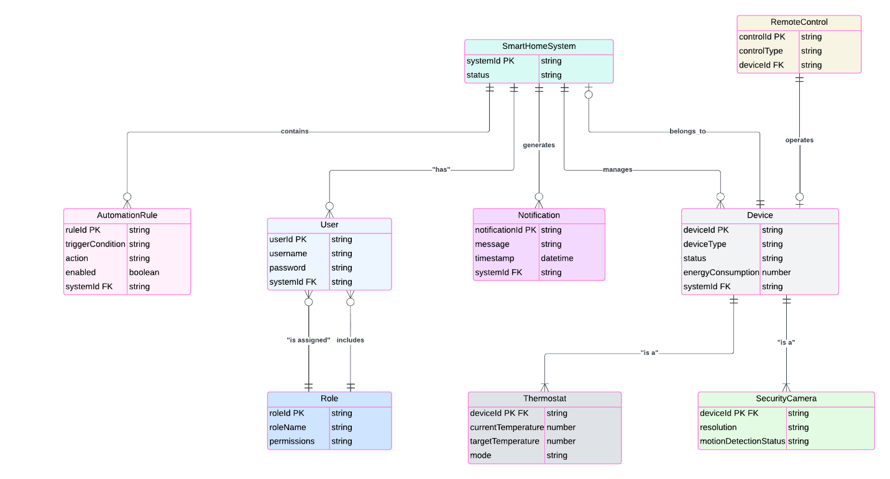

**Use Case diagrams:**

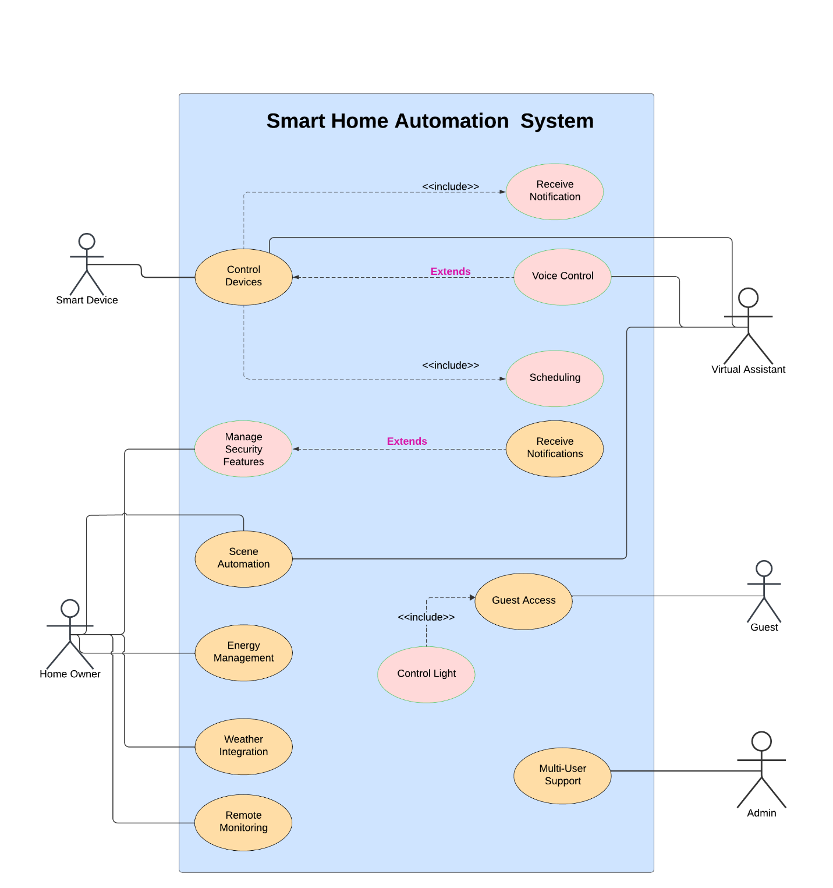

**Sequence diagrams:**

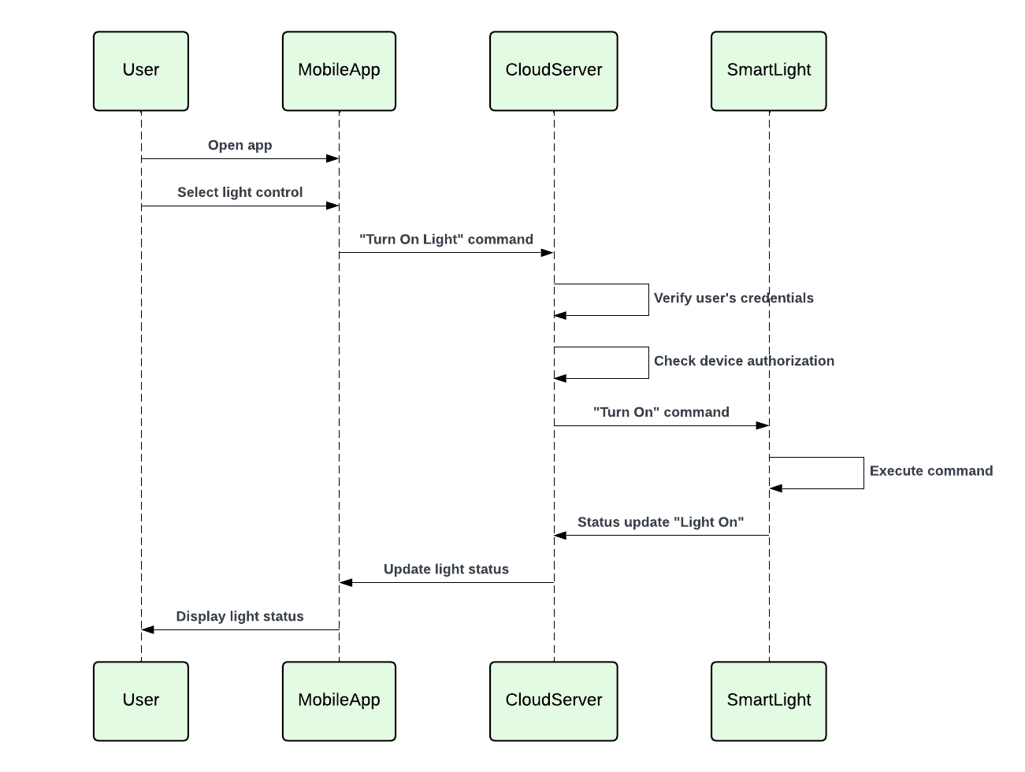

**Activity diagrams:**

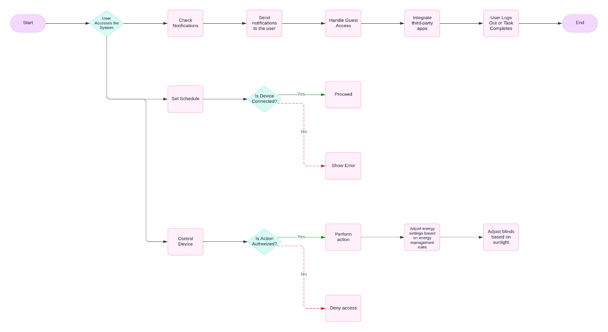

**UML Class diagrams:**

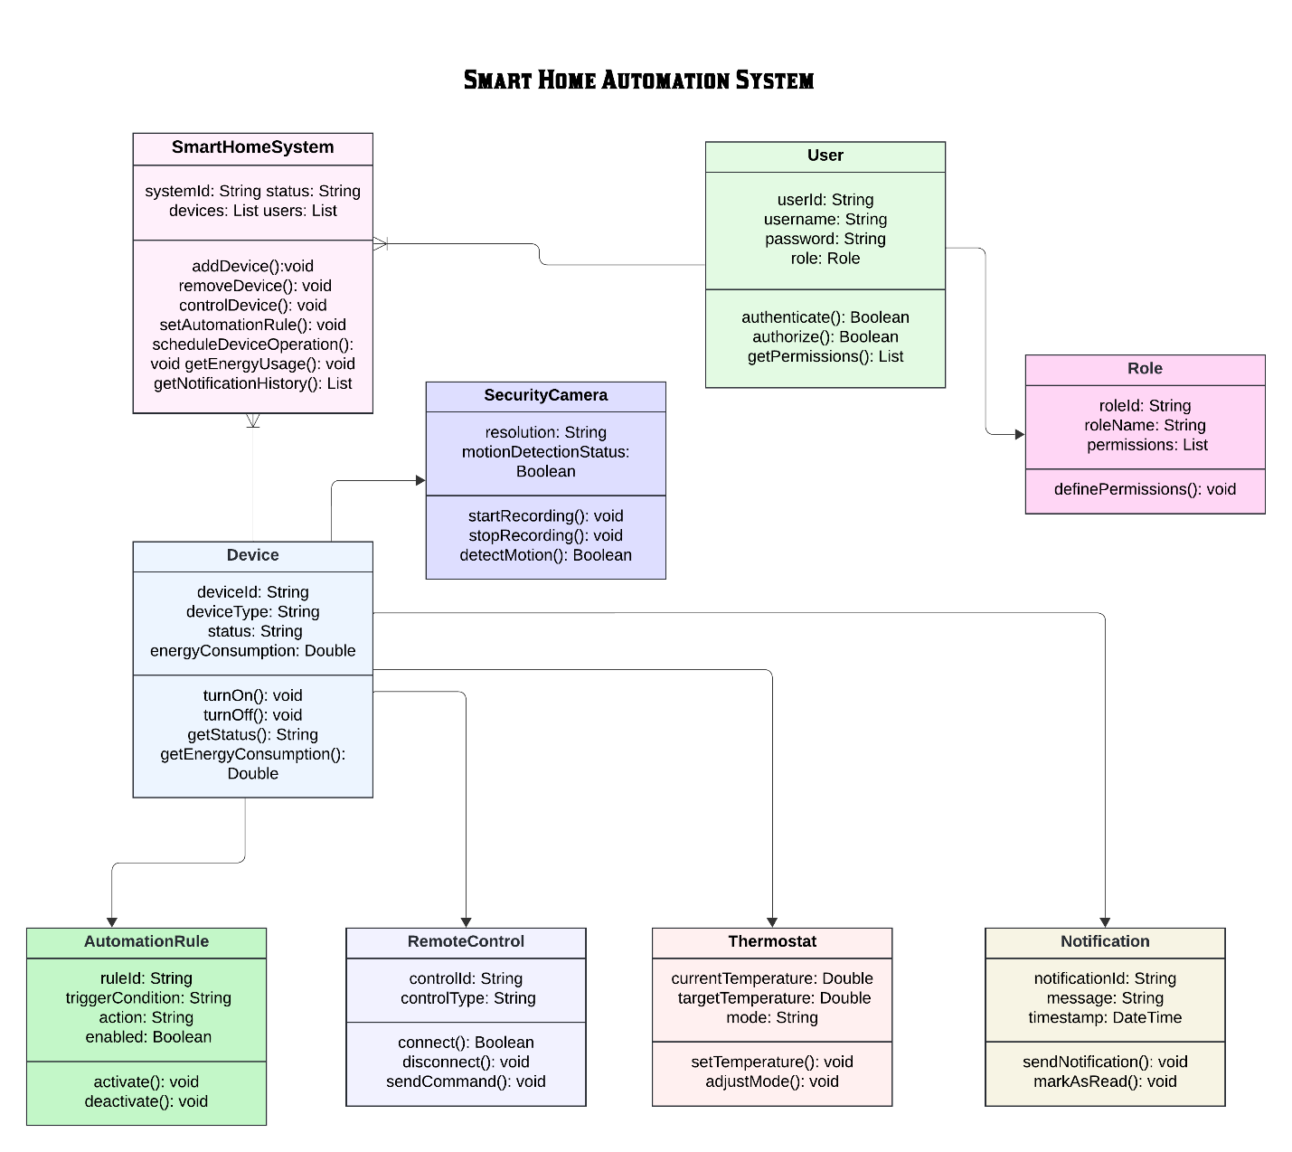

**Home Automation System Project Gantt Chart - Description**

The Gantt chart outlines the timeline and phases for the **Home Automation System Project**. It provides a structured overview of tasks, milestones, and their progression across different stages of development.

**Key Phases:**

1. **Requirements Analysis (Completed)**
   * Tasks: Identifying user needs, documenting features, and finalizing project scope.
   * Status: All tasks marked as **Done** by early November.
2. **System Design (Completed)**
   * Tasks: Creating system diagrams and finalizing UI/UX design.
   * Status: Fully **Done** by mid-November.
3. **Hardware Setup (Ongoing)**
   * Tasks: Selecting and procuring devices, installing sensors, and configuring connectivity.
   * Status: Currently **On-Going**, with completion projected by April.
4. **Software Development (In Progress and Upcoming)**
   * Tasks: Developing mobile and web interfaces and backend system (server, database).
   * Status: Interface development is **On-Going**, while backend work is **Upcoming** in late March.
5. **Testing & Deployment (Upcoming)**
   * Tasks: Functional testing, debugging, and final review.
   * Status: Testing is **On-Going**, and results review will begin in April.

**Gantt Chart:**

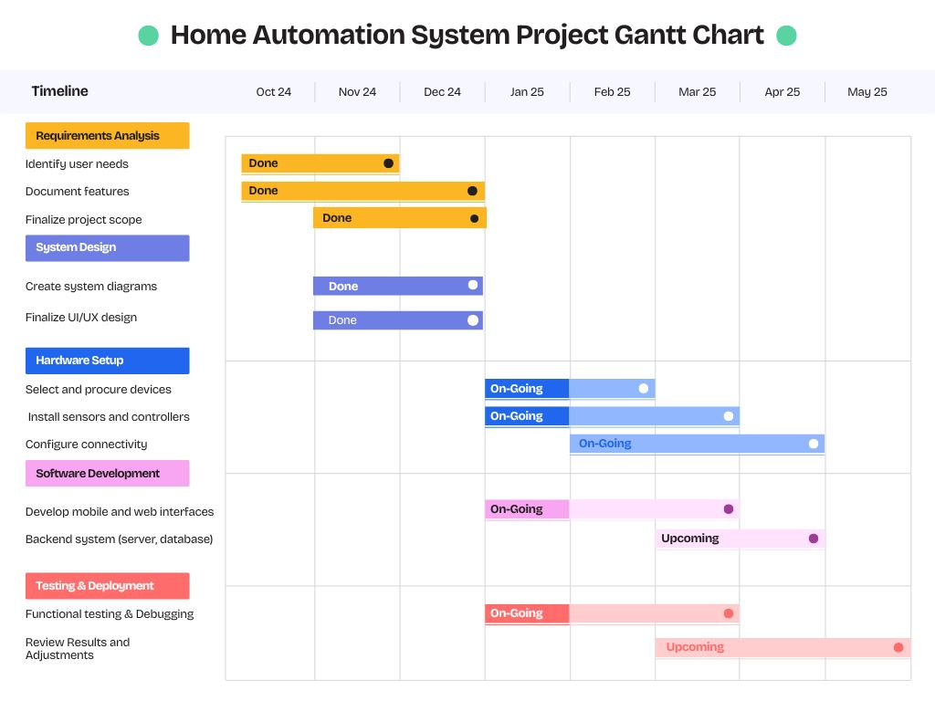

**Kayes: Use case, Gantt chart, UI(Home page ,log in ,Register)**

**Nabila: Sequence ,Activity Diagram ,UI( Profile page,Products)**

**Mamun: Er And Class Diagram,UI(Overview,Energy)**

**Prototype Snapshots**

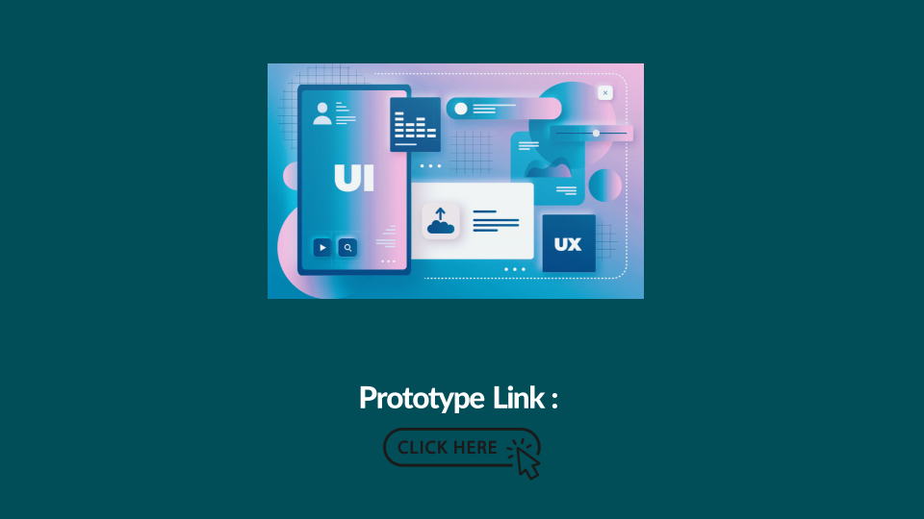

**Home Page**

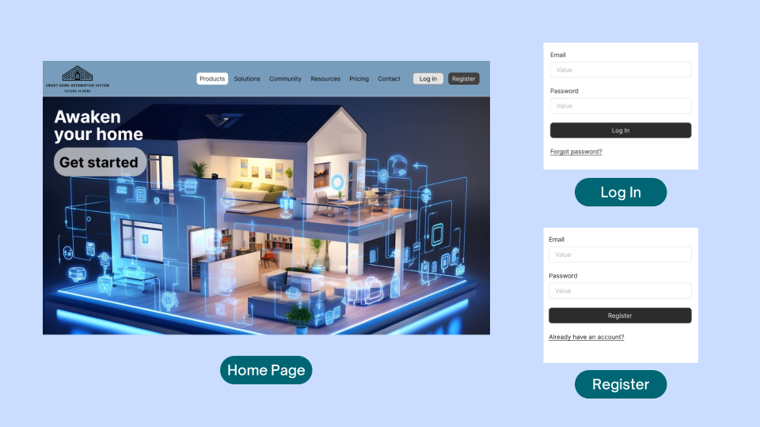

**Profile page after login**

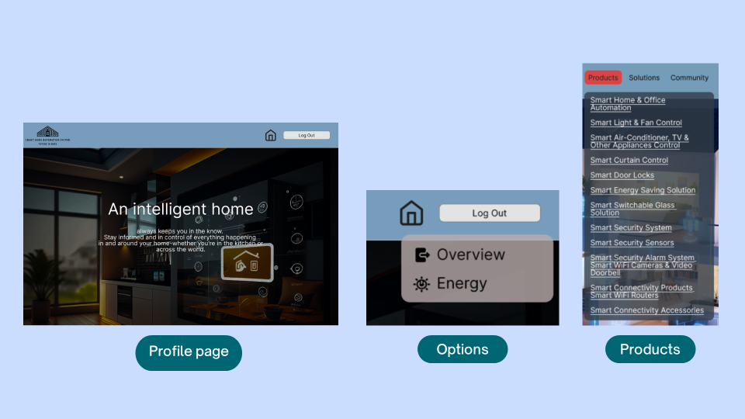

**Options**

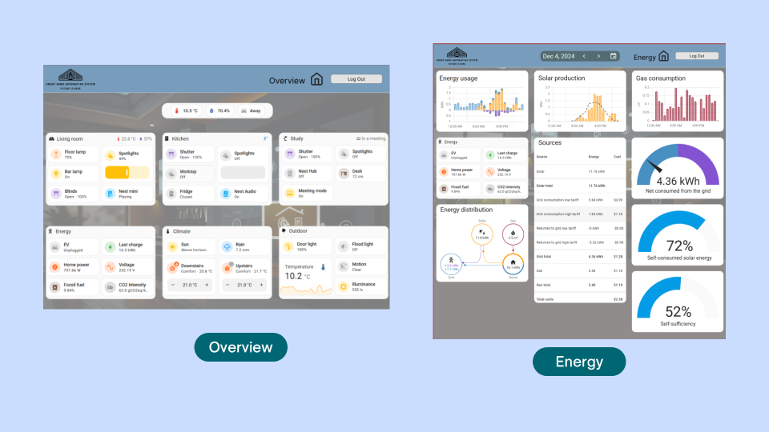

**CEP MAPPING**

**1. Knowledge Profile (K’s) addressed through our project and mapping among K’s, CO (Course Outcomes), PO (Program Outcomes):**

| K’s | Attributes | How K’s are Addressed Through Our Project | CO | PO |
| --- | --- | --- | --- | --- |
| K4 | Specialist Knowledge | We need Machine Learning and Artificial Intelligence knowledge to build a suitable predictive model for both smart home automation and real estate values, providing a data-driven solution. | CO1, CO2 | PO1 |
| K5 | Engineering Design | We used ER diagrams, Use Case Diagrams, and Activity Diagrams to design the architecture of the project, ensuring that the system integrates smart home automation and real estate prediction effectively. | CO3, CO4 | PO3, PO5 |
| K6 | Engineering Practice | The project will be implemented in TensorFlow and Python with advanced techniques, utilizing GitHub Copilot and VS Code for development, ensuring an optimized and professional development environment. | CO4, CO9 | PO4, PO5, PO6 |
| K7 | Comprehension | The project integrates real estate predictions and smart home automation, addressing users’ needs for seamless device control and property evaluation, ensuring convenience and financial security. | CO5, CO6, CO7 | PO7 |

**2.Complex Engineering Problems (P’s) addressed through our project and mapping among P’s, CO (Course Outcomes), PO (Program Outcomes):**

|  |  |  |  |  |
| --- | --- | --- | --- | --- |
| P’s | Attributes | How P’s are Addressed Through Our Project | CO | PO |
| P1 | Depth of Knowledge Required | The project requires deep knowledge in AI techniques (K4), ER, Use Case, Activity (K5), Python programming (K6), and Social and ethical implications of technology (K7) to address and automation for smart homes, merging these areas into a seamless user experience. | CO1, CO2, CO4, CO5, CO7 | PO1, PO2, PO7 |
| P3 | Depth of Analysis Required | We focus on refining the AI algorithm for both real estate predictions and smart home device control, ensuring accurate data models for both domains, enhancing user experience and functionality. | CO1, CO2, CO3, CO6 | PO1, PO2, PO3, PO6 |
| P7 | Interdependence | The integration of smart home automation with real estate predictive analytics involves high-level interdependence, with components such as device control, AI algorithms, and real-time data analytics all interconnected. | CO1, CO3, CO7 | PO1, PO3, PO7 |

**3.Complex Engineering Activities (A’s) addressed through our project and mapping among A’s, CO (Course Outcomes), PO (Program Outcomes):**

|  |  |  |  |  |
| --- | --- | --- | --- | --- |
| A’s | Attributes | How A’s are Addressed Through Our Project | CO | PO |
| A1 | Range of Resources | The project uses a variety of resources such as data (property, user, environmental factors), smart home device control, AI tools, Python, and people (developers, users, real estate professionals). | CO1, CO4 | PO1, PO7 |
| A4 | Consequences for Society and the Environment | The integration of smart home automation enhances user convenience, energy efficiency, and security, while the predictive model promotes informed property decisions, ensuring societal and environmental impact. | CO5, CO7 | PO7 |

### Conclusion:

The **Smart Home Automation** project successfully integrates advanced technologies like Machine Learning, Artificial Intelligence, and smart home systems to address the key challenges faced by homeowners and real estate investors today. By providing a centralized platform for managing both property evaluations and home automation, this project offers a seamless and efficient solution that simplifies complex decision-making processes.

The predictive models developed for real estate analysis help users make informed property choices, while the smart home automation system enhances convenience, security, and energy efficiency within the home. By addressing issues such as disconnected devices, installation complexity, and security concerns, the project not only meets technical objectives but also delivers tangible benefits to society, enhancing the user experience and contributing to more sustainable living environments.

Overall, this project demonstrates the potential of merging real estate technology with smart home automation, offering a comprehensive solution that empowers users to make smarter, safer, and more efficient decisions in both domains. The integration of these technologies presents significant improvements in convenience, security, and financial decision-making, positioning the system as a valuable tool for modern homeowners and real estate investors.

System Design and Prototype Overview

* Use Case:

[https://lucid.app/lucidchart/103fbf60-72a4-484d-b23c-717922700a09/edit?page=.Q4MUjXso07N&invitationId=inv_5734a979-5332-4134-b669-58e81337a8c5#](https://lucid.app/lucidchart/103fbf60-72a4-484d-b23c-717922700a09/edit?page=.Q4MUjXso07N&invitationId=inv_5734a979-5332-4134-b669-58e81337a8c5)

* Activity Diagram:

[https://lucid.app/lucidchart/9d661304-c613-4618-bd3e-f4a3b0daecd8/edit?page=rR3siDJT1aFt&invitationId=inv_0f70be01-1eb4-4287-8cdd-2b45f1f15b8b#](https://lucid.app/lucidchart/9d661304-c613-4618-bd3e-f4a3b0daecd8/edit?page=rR3siDJT1aFt&invitationId=inv_0f70be01-1eb4-4287-8cdd-2b45f1f15b8b)

* Sequence Diagram:

[https://lucid.app/lucidchart/47150516-bce4-4306-b618-5d35abf4132a/edit?page=0_0&invitationId=inv_9d058042-df10-42cc-899a-8ef3553d3bc6#](https://lucid.app/lucidchart/47150516-bce4-4306-b618-5d35abf4132a/edit?page=0_0&invitationId=inv_9d058042-df10-42cc-899a-8ef3553d3bc6)

* ER Diagram:

[System Home Automation: Lucidchart](https://lucid.app/lucidchart/6f07588d-84ad-46cc-bc27-dc367c465833/edit?page=0_0&invitationId=inv_f2163e45-65ac-444c-b582-e23c471a0f48)

* Class Diagram:

[https://lucid.app/lucidchart/052070e2-9fe1-48fc-aac3-b08fe4e73762/edit?page=vE1s-5mXtsFf&invitationId=inv_87e9e5a6-f9e6-453b-be05-02f8c0cc9c4d#](https://lucid.app/lucidchart/052070e2-9fe1-48fc-aac3-b08fe4e73762/edit?page=vE1s-5mXtsFf&invitationId=inv_87e9e5a6-f9e6-453b-be05-02f8c0cc9c4d)

* Prototype:

<https://www.figma.com/proto/KsvFE91zww1xkxsvCqS9Gr/smart-home-automation?node-id=1-1064&node-type=canvas&t=UdxkpRHoR5ndW1Ct-1&scaling=min-zoom&content-scaling=fixed&page-id=0%3A1&starting-point-node-id=1%3A1064&share=1>